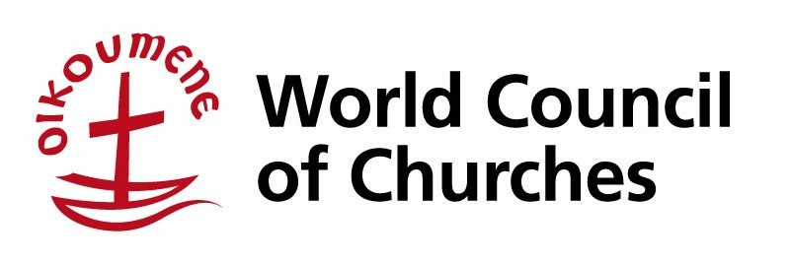

Stewards Programme

26 June – 10 July 2014
Geneva, Switzerland

What is the WCC Stewards Programme?
The stewards programme brings together a dynamic and diverse group of young people from all over the world from 26th June to 10th July, 2014 (inclusive of travel dates). At the Central Committee meeting, the stewards programme will host 30 young people from different backgrounds, churches and regions. As a community of young people from different churches, countries and cultures, stewards bring their faith, backgrounds and visions to an ecumenical experience of togetherness and friendship. Being a steward will be a challenge, will foster involvement and participation, and may indeed change your life. The stewards programme will be composed of two phases; an on-site ecumenical formation; and work at the Central Committee meeting.

Work, pray and sweat
The first phase provides dedicated time for stewards to learn about the ecumenical movement. The work done is often exhausting, intense and under pressure of short deadlines. The main areas of tasks to be carried out are: floor management, documentation, communications, interpretation, worship and other tasks such as general administration, sorting mail, delivering messages, etc. The stewards programme is only the beginning of a long process. It encourages young people to continue the journey of being ecumenical and engaging with one another.

Financing
WCC will be responsible for board and lodging expenses during the programme and will provide some pocket money. Travel costs to and from Geneva are to be borne by the steward, except in cases where subsidy is granted. Residents of following regions, if unable to finance their travel, are eligible for a subsidy: Asia, Africa, Caribbean, Central and Eastern Europe, Latin America, Middle East and Pacific.
All stewards who are granted a travel subsidy are expected to make a cash contribution towards travel expenses. The purpose of the contribution is to allow more young people to participate in the programme, to strengthen the commitment of the participants and encourage the ownership of the programme by the participants and their local churches and organisations.
Please complete the relevant section of the application form concerning travel clearly. Specific requests for assistance will be dealt with on a case by case basis. Passport, visas and any other personal related expenses are the responsibility of the selected applicant.

Criteria
Stewards have to be between 18 and 30 years old. English is the working language of the programme and its knowledge is required from the applicants. Stewards need to be prepared to endure an intensive programme of activities and long, tiring work days. Working hours are irregular, and often special programmes are planned after work for the stewards. Patience, ability to work with people from other countries and cultures, and a willingness to work together as a team, are essential. The deadline for application is 21 February 2014.

Steward Application Form
Please, type or write clearly (in English). A complete application form may be sent along with the required enclosures by e-mail or printed and sent by post or fax.
Due to the volume of applications received we cannot acknowledge receipt of each individual application. Thank you for your patience and understanding.
Family name(s) (as in passport)
First name(s) (as in passport)
Address
Postal Code Town
Country
Home telephone Mobile number
(country code/area code/number) (country code/number)
E-mail
Gender [ ] Male [ ] Female
Marital status (for insurance purposes) [ ] Single [ ] Married
Indigenous person [ ] Yes. If yes, please specify your people/tribe/nation
Date of birth (day/month/year)
Denomination / church family
Name of the national church of which you are a member
Profession or occupation (if student, which field)
Nationality (country issuing your passport) Passport number
Date and place of issue of the passport Passport valid until
(day/month/year) (day/month/year)
Mother tongue
Other languages spoken fluently
Special skills

Special needs
(disability, medical condition, dietary needs, etc.)
Please answer the following questions on a separate sheet (200 words maximum for each question):
- Briefly describe yourself and how did you find out about the WCC stewards programme?
- Why are you interested in the ecumenical movement?
- What is your involvement in youth work with your church at a local, national or international level?
- What are the main concerns facing young people in your country? Name three.
- Give an example of how ecumenism is lived in your local context.

To be completed by residents of Australia, Japan, New Zealand, North America and Western Europe: (Please put “X” sign next to the statement below)
[ ] I confirm I will cover my travel expenses fully, if selected.

To be completed by residents of Asia, Africa, Caribbean, Central and Eastern Europe, Latin America, Middle East and Pacific (Please put “X” next to one of the statements)
[ ] I confirm I will cover fully my travel expenses, if selected
or
[ ] I apply for a travel subsidy. If selected, my cash contribution towards travel expenses is USD
(If you apply for a travel subsidy you must indicate the amount you are ready to contribute)

Please enclose:
- a letter of recommendation from your church / national council of churches / ecumenical youth organisation,
- a photocopy of passport, identity card or birth certificate.

Commitment: (Please put “X” next to all of the following statements)
[ ] I confirm that I will stay for the full duration of the stewards programme.
[ ] I understand that the WCC will provide board and lodging for the period of the programme. Any other expenses, including passport and visa(s) costs, local/national travel related expenses such as vaccinations, luggage insurance or telecommunication costs, are my own responsibility.
[ ] I confirm that I will contribute to the work of my church/National Council of Churches/Ecumenical Youth Organization after the WCC Stewards Programme.

Date Signature

Send your application to: | World Council of Churches  Youth/Stewards Programme  150, route de Ferney - PO Box 2100  1211 Geneva 2, Switzerland  Tel: +41 22 791 6008  Fax: +41 22 710 2057  E-mail: wccstewards@gmail.com  Web: www.oikoumene.org/en/what-we-do/youth | Only applications which are fully completed, accompanied by the mentioned enclosures and received on time will be considered. Please do not send your application more than once.  Deadline: 21 February 2014.

